Velocity Conference 2015

# What is Velocity all about?

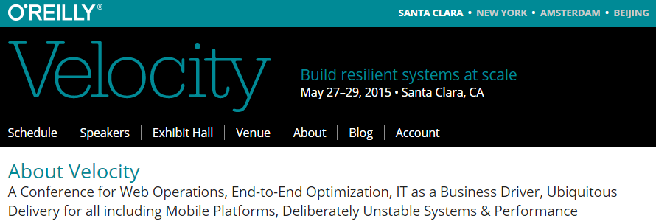

# What did I learn?

Service Workers: The Practical Bits  
by Patrick Meenan (Google) @patmeenan  
http://www.slideshare.net/patrickmeenan/service-workers-for-performance

* They are effectively a man in the middle for your page, hence HTTPS only
* Most benefit for single page apps for offline support

Putting Performance Best Practices Together to Create the Perfect SPA  
by Chris Love (Love2Dev) @ChrisLove  
http://www.slideshare.net/docluv/putting-performance-best-practices-together-for-a-spa

* "We have created the web in our own image, and it is obese"
* Modern web hourglass, web tier is now thin, smarts moved to browser

Metrics, metrics everywhere (but where the heck do you start?)  
by Tammy Everts & Cliff Crocker (SOASTA) @tameverts @cliffcrocker  
http://www.slideshare.net/CloudTest/metrics-metrics-everywhere-but-where-the-heck-do-you-start

* The myth of the single metric
* Four roles (CEO, Operations, Developer, User)
* Sunburst chart how do visitors move through my site

Linux Performance Tools  
by Brendan Gregg (Netflix) @brendangregg  
http://www.slideshare.net/brendangregg/velocity-2015-linux-perf-tools

* Value of mentoring (vs self-teaching through search) is mentor telling you what not to worry about
* Perf events mixed mode can show stack traces of both Java and native system calls

Continuous Delivery in Financial Training  
by David Genn (IG) @david_genn

* Separate deployment from release
* Automate everything
* Trust your tests
* Conversations are way better than project proposals
* Start small, be brave quickly
* Seize opportunities

Great, you're now a software company. Now what?  
Patrick Lightbody (New Relic)

* Monitoring evolved from servers and networks to applications to what users do with applications

Reflections on mountain moving, from the first year of USDS  
Mikey Dickerson (Federal Government | United States Digital Services Team)

* The more simple, the better off you are
* Agile is tactic not religious credo
* You have to make it easy for people who have been part of the problem to come along

Changing the Laws of Engineering with GitHub Pull Requests  
by Ralph Bodenner (New Relic)  
https://bit.ly/pull-request-your-culture

* How you change your process matters
* Terms: culture, metaprocess, process, entropy
* Actively discourage email: it is exclusive

# Where there any key themes?

* Real User Monitoring: more valuable than any other metric
* Web Performance: 2 seconds is the magic number

# Whom did I meet?

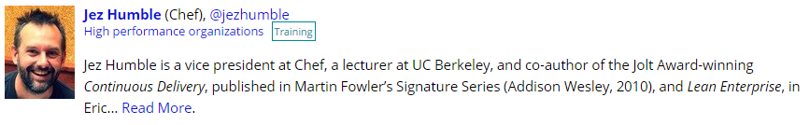

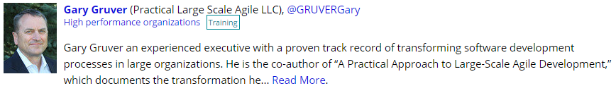

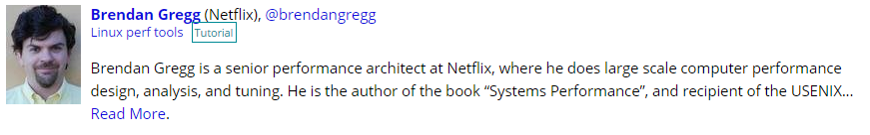

# Attributions and References

[1] Speaker Slides and Videos:  
<http://velocityconf.com/devops-web-performance-2015/public/schedule/proceedings>

[2] YouTube Playlist:  
<https://www.youtube.com/playlist?list=PL055Epbe6d5Y86GSg3nhUH3o_v62FGpCI>